Consent to publication

All the authors named in the submission attached give consent to publication of this article. All the authors declare that they have made significant contributions to (i) conception, design, analysis and interpretation of data; (ii) drafting the article or revising it critically for important intellectual content and (iii) final approval of the version to be published.
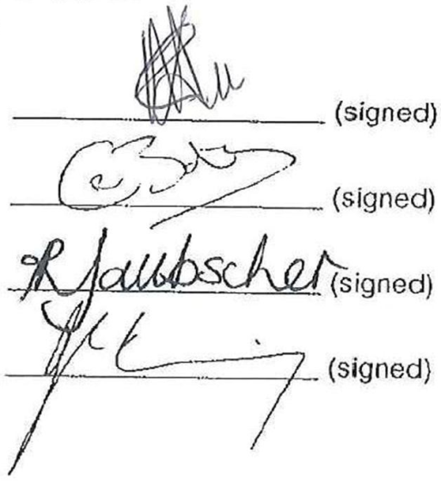
Author name
Leanne Tee ______________________ (signed) 14 October 2014 (date)

Chrisna Botha ______________________ (signed) 14 October 2014 (date)

Ria Laubscher ______________________ (signed) 14 October 2014 (date)

Johann Jerling ______________________ (signed) 14 October 2014 (date)

